Dear Hattie,

We presented CLASS at Student Technology Conference.

Presently, we are setting up a Global Orchard honoring global educators who presented at Student Technology Conference. We would like to plant a tree in your honor.

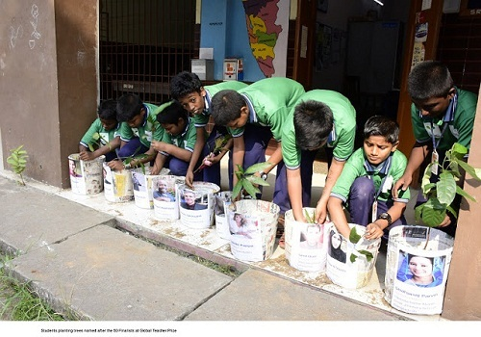
Please send us (URL to your school's website or) a photograph of your school, name and details of your school to enable us to dedicate the tree to you and your institution.

My email address is sebastianpanakal@gmail.com
My Skype name is sebastianpanakal

